Hamza Salahuddin
24k-3065
Lab-06
Task-1
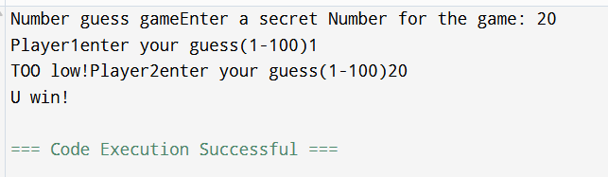

#include <iostream>
using namespace std;

void guessNumber(int target,int player){
int guess;
cout<<"Player"<<player<<"enter your guess(1-100)";
cin>>guess;

if(guess==target){
cout<<"U win!";
return;
}
if(guess>target){
cout<<"TOO high!";
}else{
cout<<"TOO low!";
}
int nextplayer;
if(player==1){
nextplayer=2;
}else{
nextplayer=1;
}
guessNumber(target, nextplayer);
}
int main(){
int target;
cout<<"Number guess game";
cout<<"Enter a secret Number for the game: ";
cin>>target;
guessNumber(target,1);
return 0;
}
Task-04
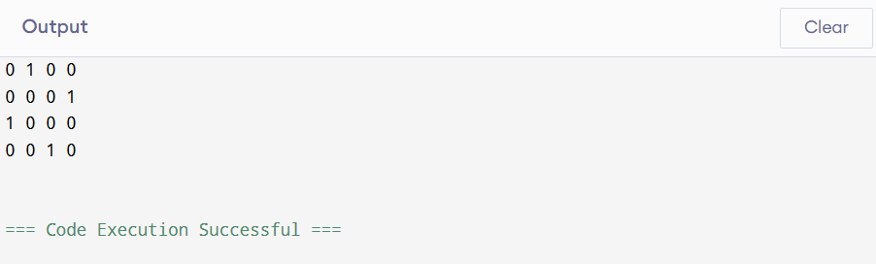
#include<iostream>
using namespace std;
#define N 4

bool isSafe(int board[N][N],int row,int col){
int i,j;
for(i=0;i<row;i++){
if(board[i][col]){
return false;
}
}
for(i=row , j=col ; i>=0 && j>=0 ; i-- ,j--){
if(board[i][j]){
return false;
}
}
for(i=row , j=col ;i>=0 && j<N;i--,j++){
if(board[i][j]){
return false;
}
}
return true;
}

bool solveNqueen(int board[N][N], int row){
if(row>=N){
return true;
}
for(int i=0;i<N;i++){
if(isSafe(board,row,i)){
board[row][i]=1;
if(solveNqueen(board,row+1)){
return true;
}
board[row][i]=0;
}
}
return false;
}
void printSolution(int board[N][N]){
for(int i=0;i<N;i++){
for(int j=0;j<N;j++){
cout<<board[i][j]<<" ";
}
cout<<endl;
}
}
bool solve(){
int board[N][N]={0};

if(!solveNqueen(board,0)){
cout<<"No solution";
return false;
}
printSolution(board);
return true;
}
int main(){
solve();
return 0;
}

